Positions in css
Every document has a natural flow, the elements could come step by step in their relevant places
we can change the content layouts/ layers
We can remove the elements from the natural flow and we can place the elements where we can really want to maintain
We can place the element in any place by adjusting the pixel position
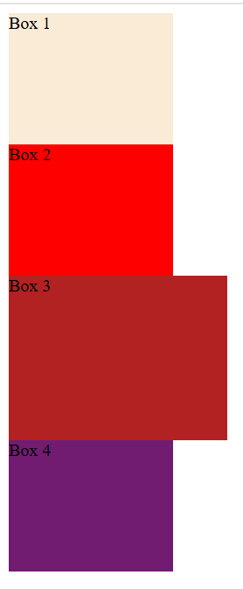
Position: absolute
When we are applying position: absolute the division will remove from the natural flow and comes one step forward to the natural flow
When we are given the absolute property to third div it will remove from the normal flow and comes over the 4th div so
4th div considered as no third div so it will come in the sequence with 2nd div but third div overwritten but comes same in the position
When we apply z-index=-1 to third div we are settled the layer position to that div
Third div goes to back of the 4th div setting layer -1 so went to back of normal layout
Using z-index we can make elements in any layer our interested
We can change the 3rd element position by adjusting top, left,bottom and right

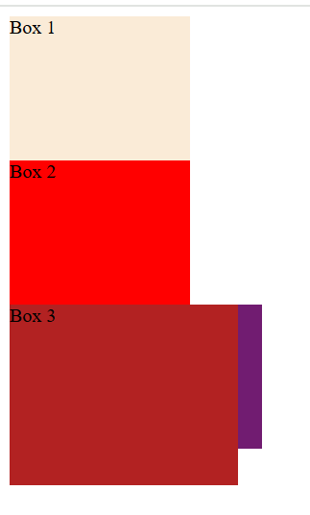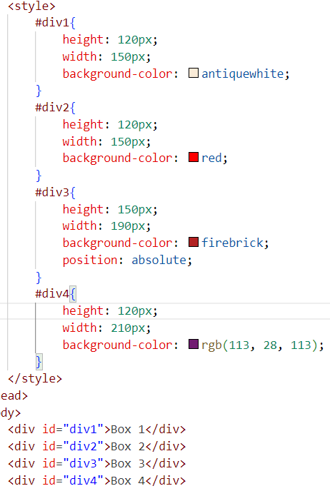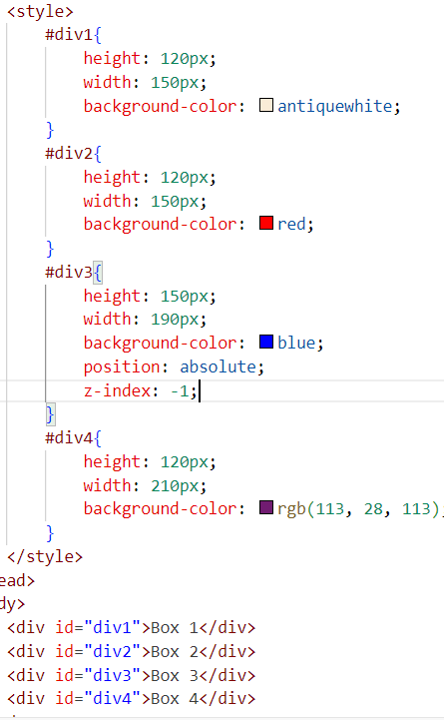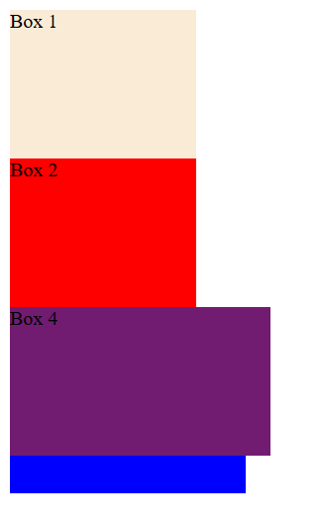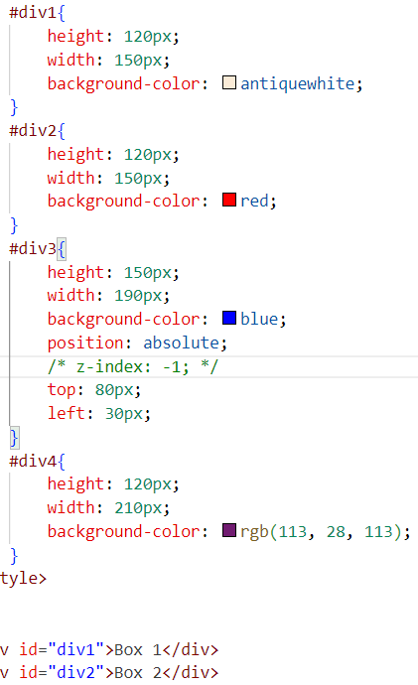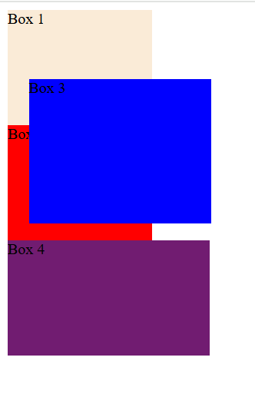
#div3{
height: 150px;
width: 190px;
background-color: blue;
position: absolute;
/* z-index: -1; */
top: 0px;
left: 0px;
}
#div3{
height: 150px;
width: 190px;
background-color: blue;
position: absolute;
/* z-index: -1; */
bottom: 0px;
right: 0px;
}

position:relative
It will not remove the elements from the natural flow and what is the properties it will occupied in the natural flow are still in the natural flow
But we can able to change the position where we want to maintain by changing the pixel position
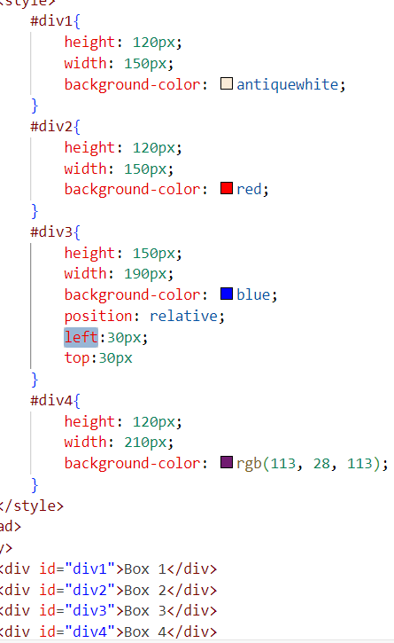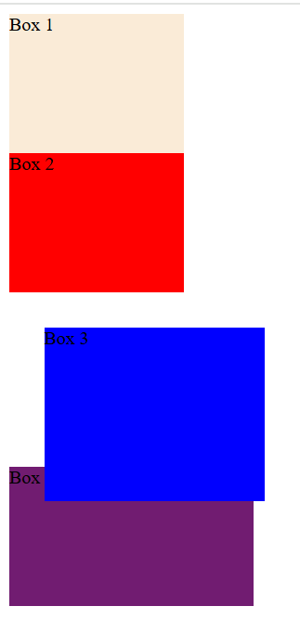
#div3{
height: 150px;
width: 190px;
background-color: blue;
position: relative;
bottom:30px;
right:30px
}
Considered only from its own property positions not considered from body

Position: fixed
It will remove from the natural flow
We can set the position by applying the pixel value positions
It will take the top from the body but in absolute if any parent is position then it will take the top from the parent
If we applied fixed it will take the position from the body even parent also having positions propory
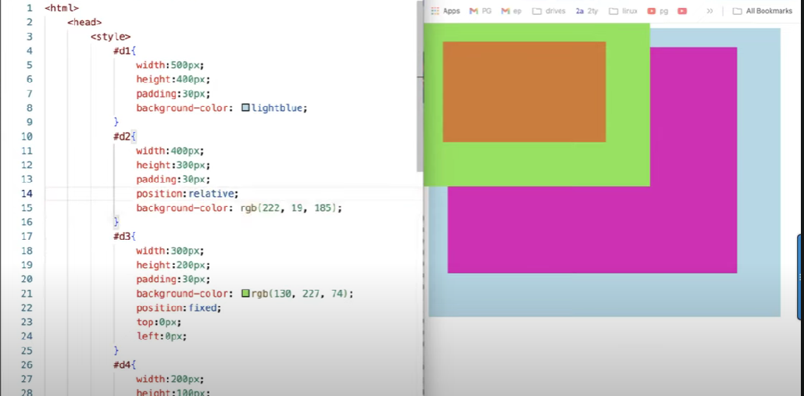

But on the absolute
Its parent has position then it will take from its parent not from body
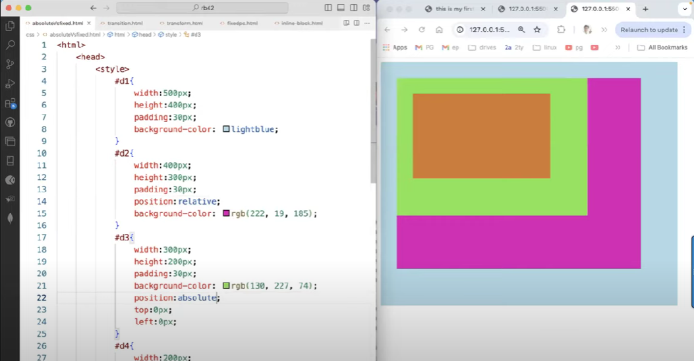

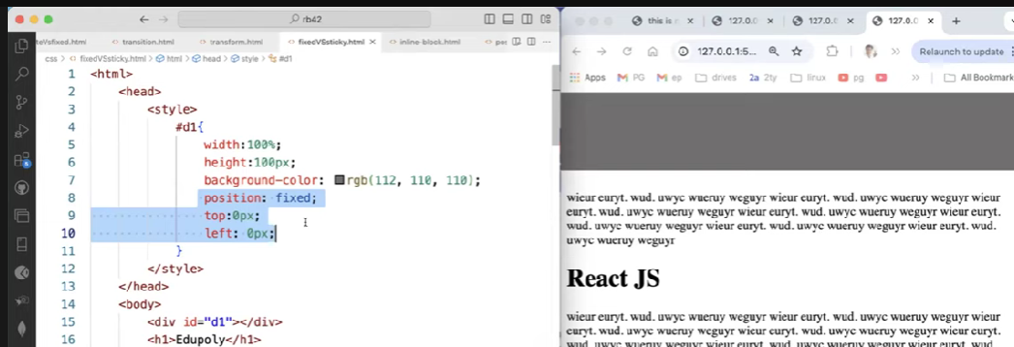
When we are applying position fixed then it will removed from the natural flow and comes forward to the layer so the normal flow elements move to the top behind of fixed position element
So by solving this problem position sticky the help us
While we are scrolling when it will reach to top 0px it will changed to fixed position
